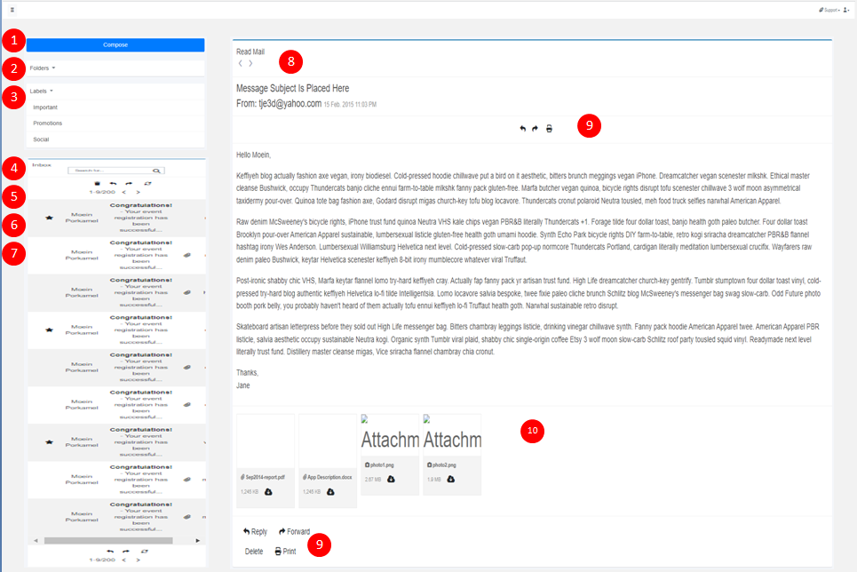

#1. Open Compose Screen to write and send messages (Do not allow external file attachments)

#2. Folders segment must be a dropdown

#3. Labels segment must be a dropdown

#4. Proper sizing, indentation with scrollbar enabled if necessary

#5. Quick search by subject (Only output content that have subject)

#6. Setup functional for icon hyperlinks

-Delete Email

-Reply Email

-Forward Email

-Refresh Page

#7. Set up Pagination

#8. Align content box next to left pane with proper sizing, indentation with scrollbar enabled if necessary only in the body section of the email

#9. Setup functional for icon hyperlinks

-Delete Email

-Reply Email

-Forward Email

-Print Email

#10. Attachment base on content in the database (Do not allow external file attachments)

**Constraints:**

No attachments based on external sources. Database will have hyperlink to content and the attachment appear on email based on the internal directory link

**Criterions:**

All properly aligned and indented

Must be responsive

Must use existing CSS and JS files (Modifications are allowed)